Smart Restaurant Management with Generative AI
WACP AI Capstone Project 2024-25

Project Details
- Project Title: Smart Restaurant Management with Generative AI
- GitHub Repository Link:https://github.com/pra123134/IDAI1_1000260_prakhar_capstone_final-120108.git

- Student Name: [Prakhar Sharma]
- Candidate Registration Number: [IDAI11000260]
- CRS Name: Artificial Intelligence
- Course Name: [Capstone Year 1]
- School Name: [Ryan Global School Kharghar]

1. Problem Identification
The restaurant industry faces multiple operational inefficiencies that impact revenue and customer experience, including:
- Limited Menu Adaptability: Menus do not dynamically adjust based on customer preferences or seasonality.
- Inventory Management Gaps: Inefficient tracking causes stock shortages and food wastage.
- Customer Engagement Deficiencies: Restaurants lack AI-driven recommendations and loyalty programs.
- High Operational Overheads: Event planning, promotions, and coordination remain highly manual.

- Long wait times impact customer satisfaction.
- Inconsistent service and manual order errors.
- Inefficient demand prediction and inventory.
- Traditional systems lack smart automation.
This project presents a Smart Restaurant Management System integrating Generative AI for personalized dining experiences, operational automation, and real-time data-driven decision-making.

2. Project Objectives
This AI-driven system aims to:
- Generate Dynamic Menus: Utilize AI to suggest personalized menu options based on user preferences and food availability.
- Enhance Digital Marketing: AI-generated promotions tailored to customer behavior.
- Enable Visual Search: Customers can search for dishes using AI-powered image recognition.
- Automate Event Management: AI assists in restaurant event planning and customized scheduling.
- Improve Inventory Forecasting: AI models predict stock requirements to reduce wastage.
By implementing these features, restaurants achieve cost efficiency, enhanced engagement, and improved customer satisfaction.

3. AI Techniques and Model Architecture

Key AI Models Used:
- Gemini 1.5 Pro: Powers AI-driven recommendations and automates event planning.
- Behavioral Analysis Algorithms: Enables customer segmentation and targeted loyalty programs.
- Visual Recognition Models: Identifies dishes from images and suggest recipes.
- AI-Driven Gamification: Encourages engagement with interactive culinary challenges.

4. System Features and Functionality

For Chefs:
- AI-Powered Recipe Suggestions: Auto-generates dish ideas based on inventory and trends.
- Culinary Challenges: AI-driven cooking competitions to boost creativity.

For Managers:
- Automated Event Planning: AI-generated event themes, menus, and marketing.
- Smart Inventory Management: Real-time tracking and predictive restocking alerts.
- Food Waste Reduction: AI suggests ways to utilize leftovers effectively.
- Personalized Marketing: AI-based promotions tailored to different customer segments.
- Training Module: Training manager and staff using CASE STUDIES

5. Market Trends and Industry Analysis

Key Market Trends:
- Growing AI Adoption in restaurant personalization and automation.
- Expansion of Dynamic Pricing Models for revenue optimization.
- Increased Use of AI-Driven Customer Engagement Tools in hospitality.

Industry Challenges:
- Limited AI Integration in real-time restaurant operations.
- Complex Event Planning requires significant manual effort.
- Inefficient Data Utilization for customer insights and personalization.

6. Technologies Used
Technology | Purpose
Gemini 1.5 Pro | AI-powered content and recommendations
Streamlight | UI development for the web application
Hugging Face | Deployment of multimodal AI models
GitHub | Version control and code management
Banana.ai | Backend AI processing

7. Data Collection and Model Training

(due to shortage of time, this phase was not conducted, a simple survey and interview from neighbering restaurant was use as the basic data)

Data Sources:
- Customer Reviews: Feedback from restaurant-goers.
- Inventory Reports: Data on stock usage and restocking patterns.
- Social Media Trends: Analysis of food trends and preferences.
- OpenMenu & Datasets: Public data for model training.

Training Workflow:

Data Collection: Extract customer preferences, inventory trends, and social insights.
- Preprocessing: Clean, structure, and format data for AI models.
- Model Training: Fine-tune AI for personalized recommendations.
- Validation & Testing: Ensure AI-generated suggestions align with customer needs.
- Continuous Learning: AI adapts to real-time restaurant data for improved performance.

Actual features implemented

Features and Functionalities
- AI Recipe & Menu Generator: Tailored recipes from inputs.
- Training Modules: Onboarding for chefs and managers.
- Gamification System: Recipe challenges & leaderboards.
- Multimodal Input Processing: Text, images, documents.
- Leftover Ingredient Management: AI reuse ideas.
- Event Planning: AI uses customers' preferences for event planning.

Future Improvements

- Advanced Analytics Dashboards: User behavior insights.
- Event Planning Assistant: Chatbot-led customization.
- ERM(Enterprise Resource Management) System
- Pos(Point of Sales)system
- Sales & Feedback Analytics
- Link with voice assistants like Alexa or Google Home.
- Offer multilingual support using AI.
- Track health and calories by analyzing dish images.
- Collaborate with delivery platforms for smart pricing.
- Visual Menu: AI search based on diet or images
- Generative Promotions: Smart offers and campaigns.
- Inventory Optimization: Predictive alerts.

Wireframes
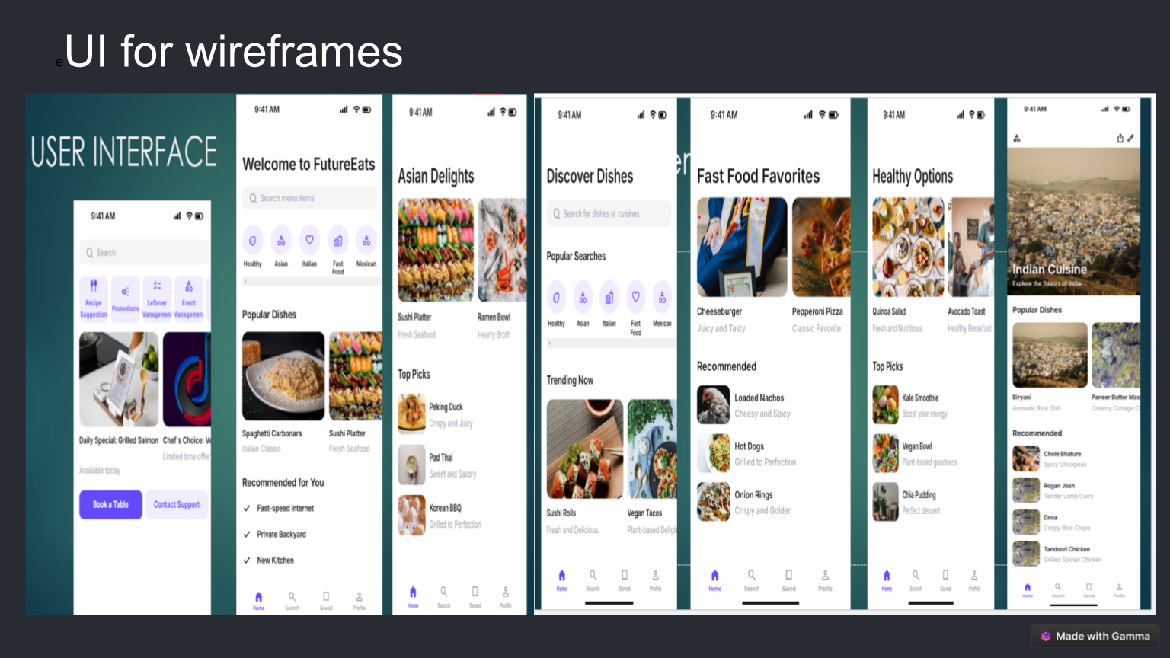
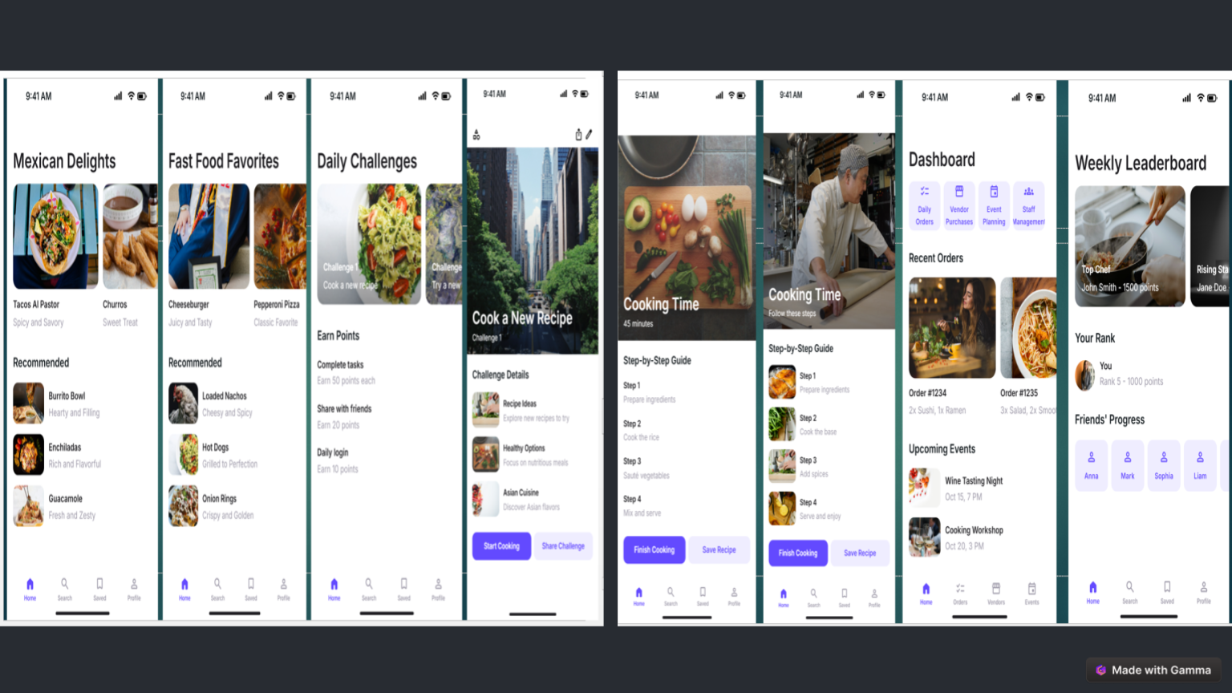
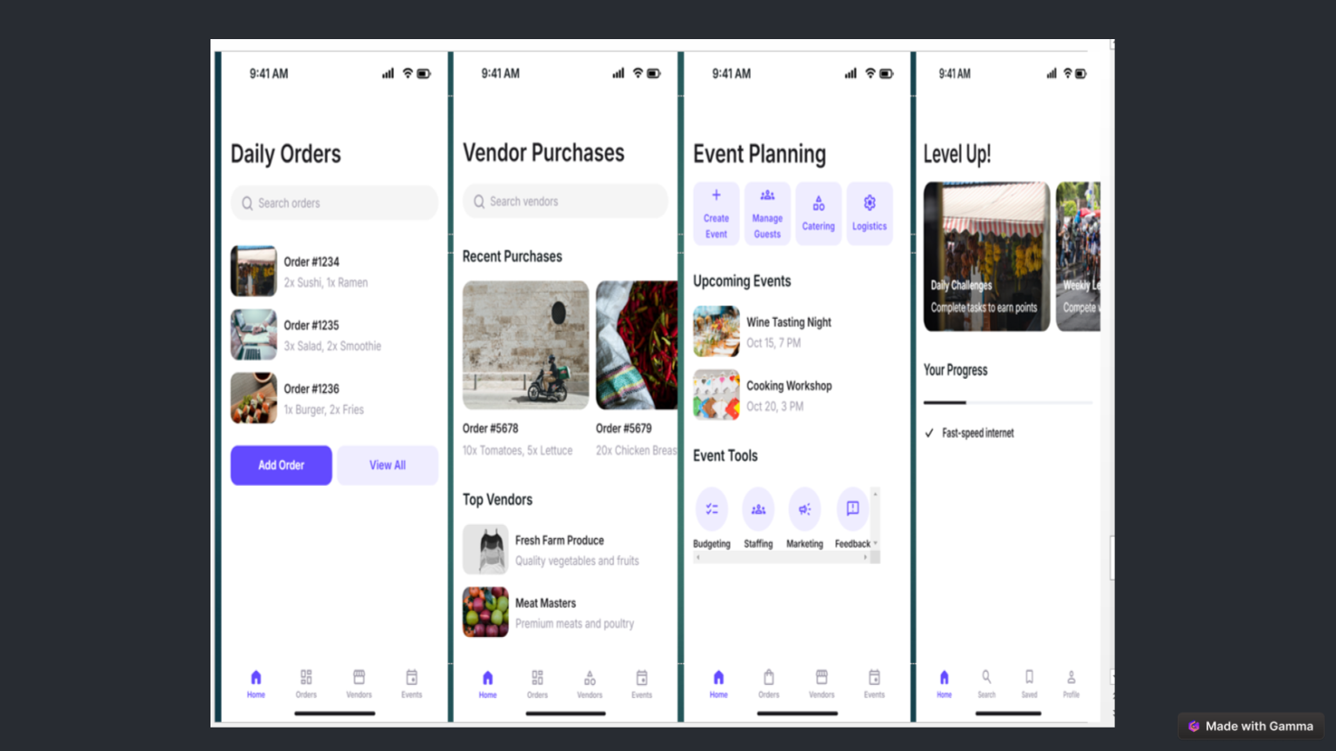

Streamlit interface
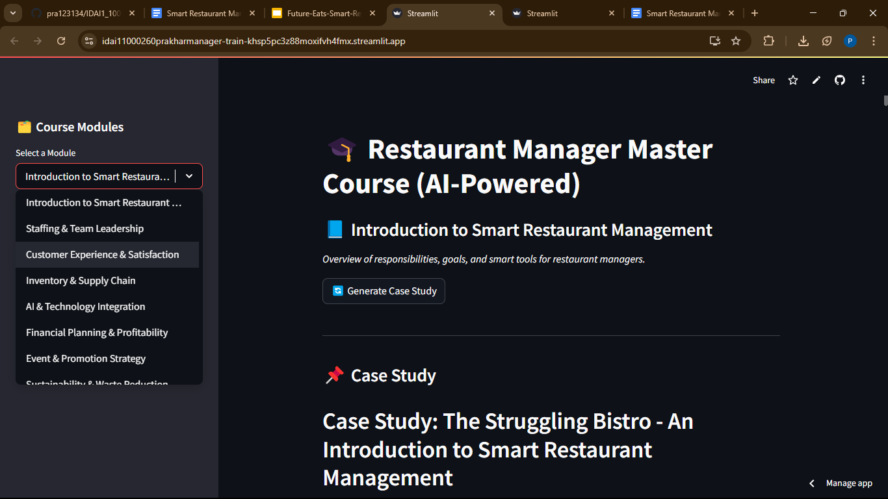
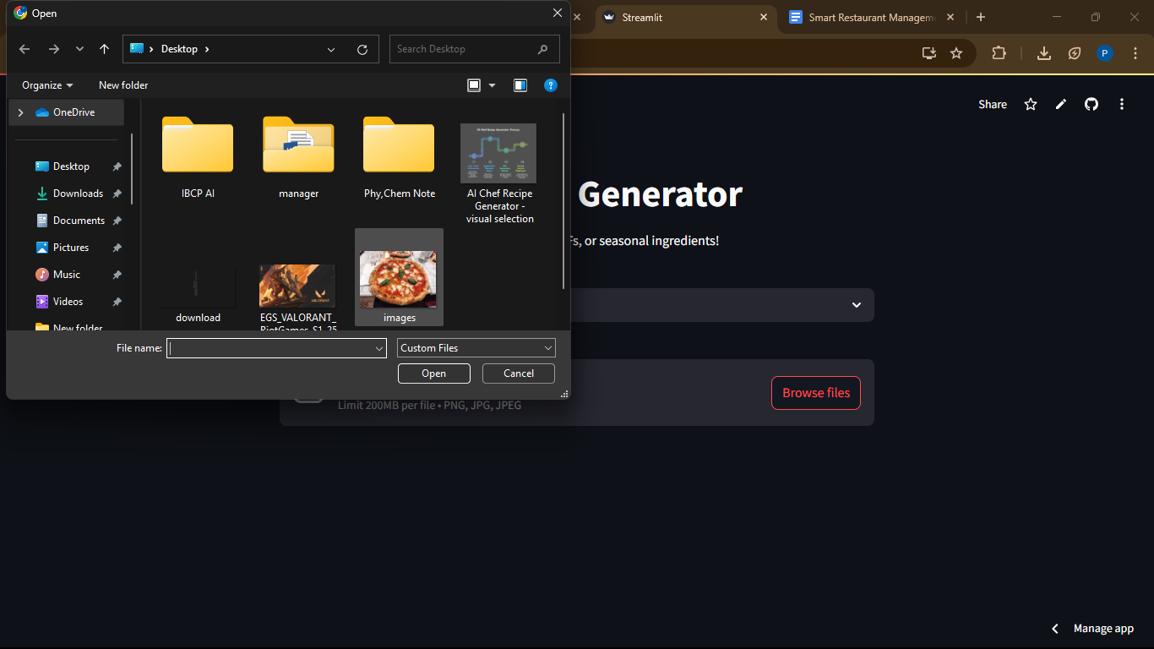
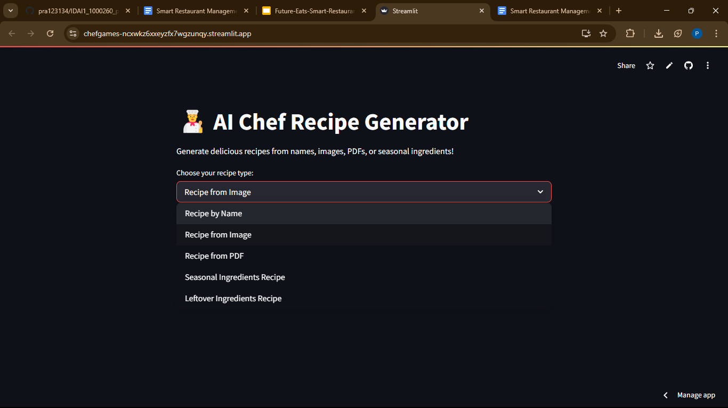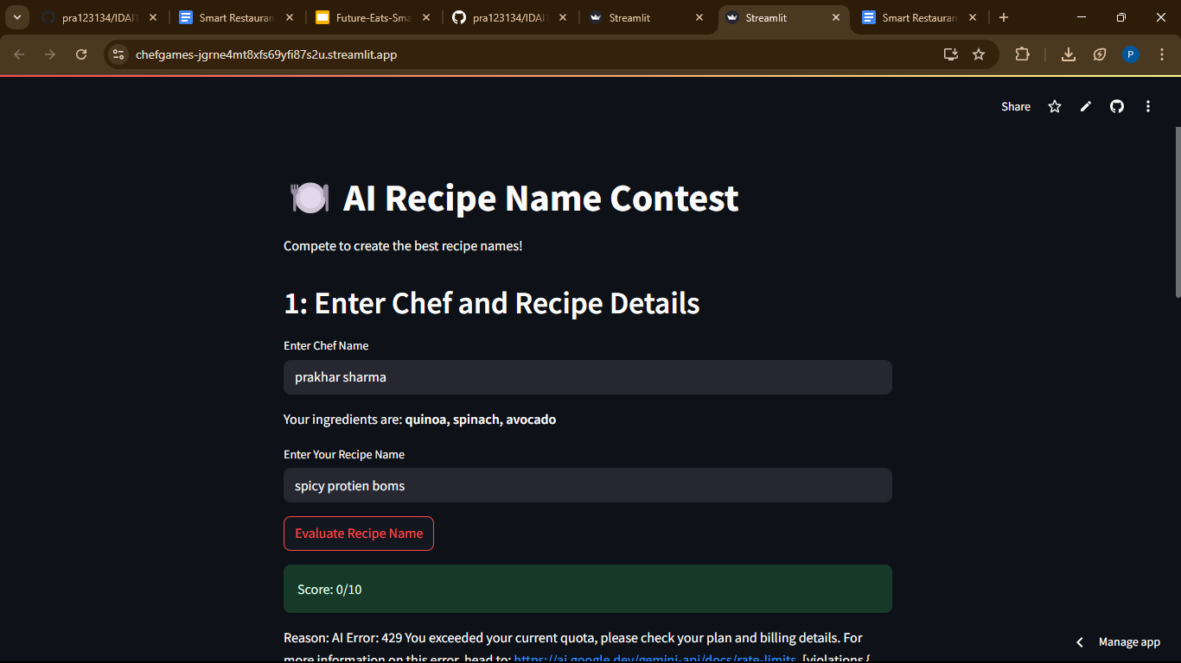
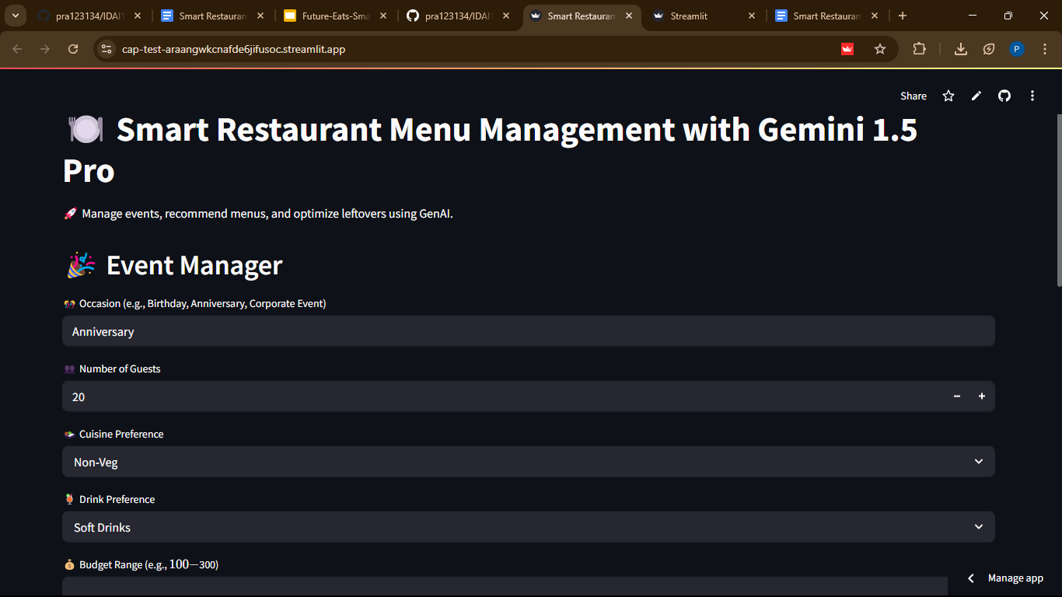

8. Testing and Deployment

Testing Procedures:
- Functional Testing: Verifies AI-generated recommendations against real-world preferences.
- Performance Evaluation: Assess the speed and accuracy of AI-driven inventory management.
- User Experience Testing: Gathers feedback from restaurant managers and staff.
(tested and verified the app fortraining managers using case study, and generating recipes for chef with multimodal input and gamification for chef, all are working except some issues with leaderboard display)

Deployment Strategy:
- Deployed on Streamlit.

9. Impact and Conclusion
The Smart Restaurant Management with Generative AI project demonstrates how AI can revolutionize restaurant operations through intelligent automation, enhanced personalization, and optimized resource utilization.

Key Outcomes:
- Reduced Operational Costs: AI automates routine tasks, reducing overheads.
- Improved Customer Satisfaction: Personalized recommendations enhance dining experiences.
- Efficient Inventory Management: AI-driven tracking minimizes waste and stock shortages.

Future Enhancements:
- Advanced AI Analytics: Deeper insights into customer preferences.
- AI-Powered Chatbots: Automate customer service and reservations.
- Multilingual AI Recommendations: Expanding accessibility for global users.

10. References
- AI Model Documentation - Gemini 1.5 Pro
- OpenMenu and Yelp Data APIs
- Streamlit & Hugging Face Integration Guidelines
- User Feedback Reports from Prototype Testing

